# JS Fundamentals: Test Exam

*This is a test exam for course* [*JavaScript Fundamentals*](https://softuni.bg/courses/javascript-fundamentals) *at SoftUni*

## Problem 4. Trucks

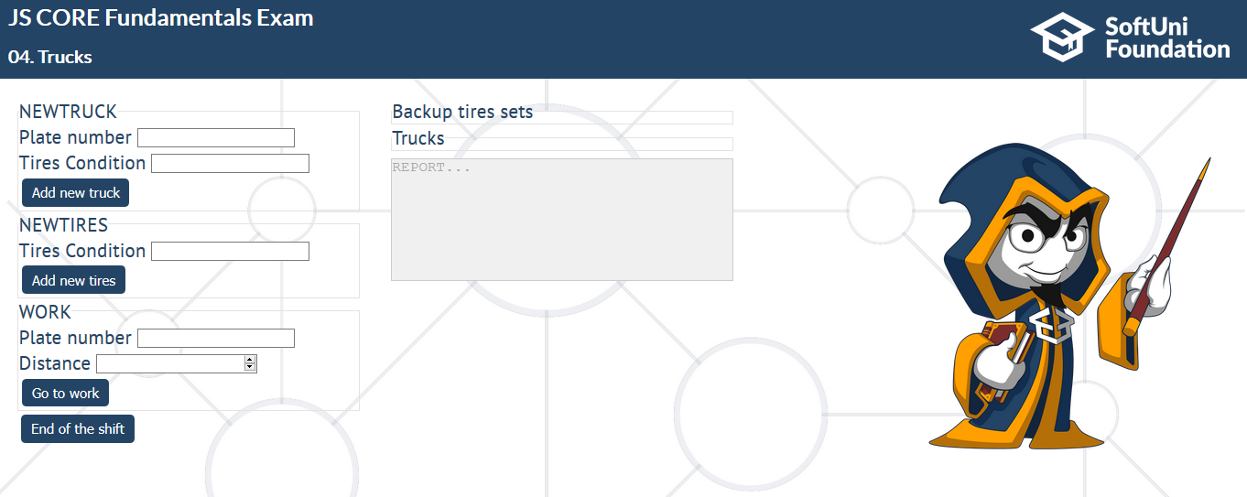

You have to keep track of all of your **trucks** and their **tire's conditions**. Each truck has a **plate number**, a total of **8 tires**, each one is a number representing **how good its condition is** and it also needs to keep track of **each trucks travelled distance**.

You will receive a **sequence** of **inputs** for, each **input** will **some information** about **one** of the following **commands**:

* **"NEWTRUCK"** – **Plate number: C111AA, Tires Condition: 5 5 5 5 5 5 5 5**  
   that means you have to **add a new truck** if you don’t have it already with the given **plate number** and the **tires**.
* **"NEWTIRES"** – **Tires Condition: 7 7 7 7 7 7 7 7** – add the given tires in a collection of **backup tires**. You might need to use them later
* **"WORK"** – **Plate number: C111AA, Distance: 7000** – that means that **if you have that truck** (with the given plate number), it **has to travel a given amount of kilometers**. Every **1000** kilometers the quality of each tire **reduces by 1**. You have to calculate if the **quality of all the tires of the truck is enough to travel that distance**.
  + If it is, **reduce the quality** of **each tire** with the **needed amount** and **add the kilometers** to the truck's **total distance**
  + If it is not, **try to change the tires** (if you have any backups) **once** and do that calculations again. If after the **change the tires the truck can travel**, do it, otherwise the **truck does not travel** and you have to proceed.

**At the end of the shift (when "End of the shift" button is clicked)**, print into **textarea element** for each truck information in the following format: **"Truck {plateNumber} has traveled {trucksDistance}."**. And finally print how many sets of tires you have as backup in the format: **"You have {setsCount} sets of tires left."**

**Note:** "**Backup" tires sets**" element into the skeleton **contains all tire sets registered like NEWTIRES**. **Every tire** **set** into "**Backup tire sets**" must be in a **div elemen**t with **class** "**tireSet**". **If** **some tire set** from the "**Backup tires sets**" is **used** you **must remove** the **div element** that **contains this set of tires**.

And "**Trucks**" element into skeleton **contains all trucks registered like NEWTRUCK**. **Every truck** into "**Trucks**" must be in a **div element** with **class** "**truck**".

### Input/Constrains

* The input will always be in a valid format

### Output

* Look at the examples for more clarity

### Examples

|  |  |
| --- | --- |
| **Input** | **Report output** |
| NEWTRUCK  - Plate number: C1111AA   * Tires Condition: 7 7 7 7 7 7 7 7   ------------------------------------------------  NEWTRUCK   * Plate number: C2222AA * Tires Condition: 5 5 5 5 5 5 5 5   ------------------------------------------------  NEWTIRES   * Tires Condition: 8 8 8 8 8 8 8 8   ------------------------------------------------  NEWTIRES   * Tires Condition: 4 4 4 4 4 4 4 4   ------------------------------------------------  NEWTIRES   * Tires Condition: 5 5 5 5 5 5 5 5   ------------------------------------------------  WORK   * Plate number: C1111AA * Distance: 7700   ------------------------------------------------  WORK   * Plate number: C2222AA * Distance: 6000   ------------------------------------------------  WORK   * Plate number: C1111AA * Distance: 3000 | Truck C1111AA has traveled 10700.  Truck C2222AA has traveled 0.  You have 0 sets of tires left. |
| NEWTRUCK  - Plate number: B1002SA  - Tires Condition: 17 17 17 17 17 17 17 17  ------------------------------------------------  NEWTIRES  - Tires Condition: 8 8 4 8 8 8 9 8  ------------------------------------------------  NEWTIRES  - Tires Condition: 4 4 5 4 4 7 4 4  ------------------------------------------------  NEWTIRES  - Tires Condition: 5 1 5 5 5 7 5 1  ------------------------------------------------  WORK  - Plate number: B1002SA  - Distance: 7700  ------------------------------------------------  WORK  - Plate number: B1002SA  - Distance: 6000  ------------------------------------------------  WORK  - Plate number: B1002SA  - Distance: 3000 | Truck B1002SA has traveled 16700.  You have 3 sets of tires left. |

